Bridging the Gap: Designing a secure and Segmented Network Infrastructure for an underserved Rural Health Clinic
IT Project Report–Final Submission
Elvie Previlma
Southern New Hampshire University
IT 700: Capstone Information Technology
June 21, 2026

The ongoing digital gap and the growing risk of healthcare cybersecurity breaches put small and rural healthcare providers serving low-income communities in a very vulnerable situation. Small clinics operating in disadvantaged communities or rural areas often rely on consumer-grade networking equipment that was never intended to handle the sensitivity or regulated complexities faced by healthcare data environments, in contrast to large hospital systems with dedicated IT departments and enterprise-grade network infrastructure. The result is a single, flat, unsegmented network with open guest Wi-Fi access points, administrative billing systems, and clinical workstations storing electronic protected health information (ePHI) all coexisting on the same network without any sort of traffic filtering, access control, or isolation. This network architecture is knowingly unsafe in addition to being technically flawed.
This flat network architecture is a clear and verifiable breach of federal law, not just a flaw in best practices. The Security Rule of the Health Insurance Portability and Accountability Act of 1996 (HIPAA) mandates that covered healthcare organizations implement technical protection to ensure the security, privacy, and accessibility of electronic patient health information (ePHI) stored in or transferred across electronic information systems (U.S. Department of Health and Human Services, 1996). Organizations are required by 45 CFR § 164.312(a)(1) to limit access to electronic health information to those who are authorized to view it. This requirement is simply and immediately broken when a patient's personal smartphone, linked to the clinic's waiting room Wi-Fi, is on the same network segment as a nurse's workstation that has the patient's medical records. Unauthorized access, data interception, and lateral network movement by attackers are all made possible by the lack of network segmentation, which removes the technical barrier between private clinical data and public access.
The significance of this issue is further enhanced by the broader context of healthcare cybersecurity in the United States. According to the U.S. Department of Health and Human Services (2023), even while small healthcare organizations nonetheless hold incredibly sensitive patient data, they are at greater risk by cyberattacks because they lack the defensive architecture of larger institutions. A single electronic health information data breach may result in HIPAA-mandated breach notifications, federal investigations, civil fines ranging from hundreds to millions of dollars depending on the level of carelessness, and permanent damage to patient trust. These consequences can result in the permanent closure of a facility that may be the only easily accessible source of medical care within a significant geographic area. They are not just financial for a small clinic operating on a low budget and serving a community with few healthcare options.
Project Design Solution:
In order to solve this issue, this project uses Cisco Packet Tracer, an industry-standard network simulation environment, to design and simulate a segmented network infrastructure that complies with HIPAA regulations (Cisco Systems, 2024). The suggested solution uses a Cisco 3560 Multilayer Switch to construct a structured three-VLAN (Virtual Local Area Network) design in place of the clinic's current flat, single-network architecture. The following is a breakdown of the three network segments: The EHR Server (192.168.10.3) and PC-Clinical (192.168.10.2) are located in VLAN 10 (Clinical), which has the subnet 192.168.10.0/24 with a gateway of 192.168.10.1; the PC-Admin (192.168.20.2) is located in VLAN 20.0/24 with a gateway of 192.168.30.1; and the guest wireless access point and patient devices in the waiting area are located in VLAN 30.0/24.
The gateway router is connected via Fa0/24, and each VLAN is mapped to a specific switch port: PC-Clinical to Fa0/1, the EHR Server to Fa0/2, PC-Admin to Fa0/3, and the guest access point to Fa0/4. The multilayer switch has IP routing enabled to enable inter-VLAN connection when allowed, and DHCP pools have been set up for each segment to guarantee accurate automatic IP address assigning. Each device obtained the correct IP address for its corresponding VLAN, as confirmed by the simulation's successful DHCP process across all three segments. The next phase of the design involves setting up an extended Access Control List called BLOCK_GUEST on the guest VLAN interface. This list will specifically prevent any traffic coming from the 192.168.30.0/24 subnet from reaching the administrative (192.168.20.0/24) or clinical (192.168.10.0/24) segments, while allowing outbound internet access for all three VLANs. This design is in line with NIST Special Publication 800-66, which offers healthcare-specific recommendations for implementing HIPAA Security Rule technical controls, and is based on the NIST Cybersecurity Framework Version 1.1, including the Protect function (NIST, 2008; NIST, 2018).
Section 2: Project Implementation
This project was fully implemented in Cisco Packet Tracer, an industry-standard network simulation environment created by Cisco Systems (2024). The simulation developed gradually across several configuration stages, each of which was validated before moving on to the next. It simulates a small rural health clinic network. A Cisco 3560 Multilayer Switch, which acts as the core Layer 3 device in charge of all inter-VLAN routing and DHCP services, is connected to a Cisco 2911 Gateway Router via port Fa0/24.
Using the Switch CLI, three Virtual Local Area Networks (VLANs) were created on the Cisco 3560 Multilayer Switch during the initial stage of implementation. Clinical operations were assigned to VLAN 10, administrative operations to VLAN 20, and patient guest Wi-Fi access to VLAN 30. The show VLAN short command was used to verify each VLAN, confirming that all three segments were active. In the second stage, certain switch ports were assigned to their matching VLANs: Fa0/1 was assigned to VLAN 10 for PC-Clinical, Fa0/2 to VLAN 10 for the EHR Server, Fa0/3 to VLAN 20 for PC-Admin, and Fa0/4 to VLAN 30 for the guest wireless access point. All ports were configured in access mode using the switchport mode access and switchport access VLAN commands.
Each VLAN interface on the multilayer switch received an IP address in the third phase: VLAN 10 received 192.168.10.1/24, VLAN 20 received 192.168.20.1/24, and VLAN 30 received 192.168.30.1/24. The no shutdown command was used to bring each interface up, and the ip routing command was used to activate IP routing globally on the switch. Setting up DHCP pools for every VLAN segment was the fourth step. Each of the three pools—CLINICAL, ADMIN, and GUEST—specified the appropriate network subnet and default gateway. Setting each end device to DHCP mode allowed for the verification of DHCP functionality. PC-Clinical received 192.168.10.2, the EHR Server received 192.168.10.3, and PC-Admin received 192.168.20.2, indicating correct address assignment across all three segments. The security enforcement layer of the design will be completed by the next and last stage of implementation, which involves configuring the extended Access Control List named BLOCK_GUEST to block all traffic from the guest subnet (192.168.30.0/24) to the clinical (192.168.10.0/24) and administrative (192.168.20.0/24) subnets.
Section 3: Project Test Plans and Results
The testing strategy for this project is focused on basic verification testing using Cisco Packet Tracer's built-in ping and display commands. The three forms of testing include DHCP verification testing, inter-VLAN isolation testing, and intra-VLAN connectivity testing. Intra-VLAN connectivity testing verifies that devices within the same VLAN can communicate with each other. PC-Clinical (192.168.10.2) should be able to successfully ping the EHR Server (192.168.10.3) in order to confirm that VLAN 10 is functioning as a shared clinical segment. This planned test will be conducted once ACL configuration is complete.
Testing for DHCP verification has already been successfully finished. Every device was set up to automatically acquire its IP address, and the outcomes verified correct assignment: The EHR Server received 192.168.10.3 with a default gateway of 192.168.10.1, PC-Clinical received 192.168.10.2 with a default gateway of 192.168.10.1, and PC-Admin received 192.168.20.2 with a default gateway of 192.168.20.1. Every DHCP request produced a "DHCP request successful" confirmation in Packet Tracer, offering proof of proper pool setting. After the BLOCK_GUEST Access Control List is applied to the VLAN 30 interface, the most important test—inter-VLAN isolation testing—will be carried out. The guest network device will ping the EHR server at 192.168.10.3 as part of this test. For this project, 100% packet loss on that ping indicates that the ACL is effectively preventing unwanted access. As proof of a working and HIPAA-compliant network design, screenshots of every test result will be taken and added to the project appendix (NIST, 2018). The guest network device will ping the EHR server at 192.168.10.3 as part of this test. For this project, 100% packet loss on that ping indicates that the ACL is effectively preventing unwanted access. As proof of a working and HIPAA-compliant network design, screenshots of every test result will be taken and added to the project attachment (NIST, 2018).
Section 4: Recommendations for Future Enhancements
Even though the current project effectively illustrates a three-VLAN segmented network infrastructure with verified guest isolation that complies with HIPAA regulations, a number of significant improvements might be made with more time and funding.
Enhancement 1: Intrusion Detection System (IDS Integration)
The biggest future improvement would be the addition of an intrusion detection system based on the network (IDS) like Snort, which would provide real-time monitoring and alerting capabilities for suspicious traffic patterns across all three VLANs. Currently, the BLOCK_GUEST ACL passively blocks undesirable traffic; it rejects packets but does not alert clinic staff or IT personnel when an unauthorized access attempt occurs. An IDS would add an active detection layer that tracks and flags any attacks in real time, changing the clinic's security posture from strictly preventative to both preventive and detective. This would be in line with the NIST Cybersecurity Framework's Detect function (NIST, 2018). Before taking this enhancement seriously, the clinic would need to either create a dedicated IT support role or partner with a managed security service provider (MSSP) capable of monitoring and responding to IDS alarms. The primary risk associated with this enhancement is alert fatigue; if the system is not correctly tuned, it may generate a huge number of false positives that overwhelm staff and cause serious threats to go undetected.
Enhancement 2: Multi-Site VPN Expansion
A second future development would be to extend the current single-site simulation to a multi-site network model. This would be in line with the reality that many rural health systems operate across multiple clinic locations that share patient and administrative data. Establishing site-to-site VPN tunnels between locations would directly address the HIPAA Security Rule's transmission security standard under 45 CFR § 164.312(e)(1) to ensure that ePHI transmitted between sites stays encrypted in transit (U.S. Department of Health and Human Services, 1996). IT staff at each location would need to be trained, a formal transition management plan in line with NIST SP 800-66 would need to be developed and approved by clinic leadership, and the single-site design would need to be verified in a physical hardware environment before multi-site expansion could be implemented (NIST, 2008). The primary risk of this improvement is increased configuration complexity; a misconfigured VPN tunnel or routing strategy across several sites could inadvertently divulge clinical data or result in network outages that compromise patient care.
Enhancement 3: Formal Change Management and Configuration Tracking
Using a formal network configuration and change management (NCCM) solution, such SolarWinds Network Configuration Manager, to manage future network change proposals, testing, and implementation would be a third potential improvement. There is currently no automated backup, version history, or rollback feature; instead, configuration changes, including ACL modifications, are made manually through the Switch CLI. Before making any changes, an NCCM tool would automatically backup the switch's current configuration, keep a complete audit history of who made each change and when, and allow an instant backup to the last known-good configuration in the event that a later modification unintentionally interferes with clinical network access.
This immediately addresses the systematic information risk assessment requirement for change management procedures by guaranteeing that any future modifications to the BLOCK_GUEST ACL or VLAN structure are tracked, reversible, and auditable. Before implementing this upgrade, the clinic would need to explicitly identify a network change owner and establish a change approval procedure. This could be accomplished by monitoring and approving change requests before they are implemented on the live switch configuration using a tool like Jira. The primary risk to consider is the additional administrative burden of a formal change procedure, which must be balanced against the clinic's limited IT staffing resources to prevent creating a bottleneck for routine, low-risk improvements.
Section 5: Appendix–Supporting Evidence of Project Implementation
The following visuals represent the network simulation that was developed, configured, and tested in Cisco Packet Tracer during the project's implementation and testing phases.
Figure 1, VLAN Creation and Port Assignment–show VLAN brief output confirming VLAN 10 (clinical, Fa0/1), VLAN 20 (Administrative, Fa0/2), and VLAN 30 (Guest, Fa0/3) are active.
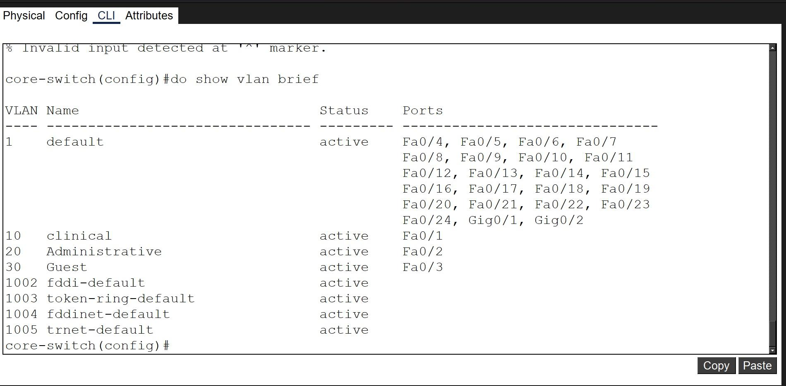
Figure 2. VLAN IP Addressing–show IP Interface brief output configuring VLAN10 (192.168.10.1), VLAN20 (192.168.20.1), and VLAN30 (192.168.30.1) are all up/up.
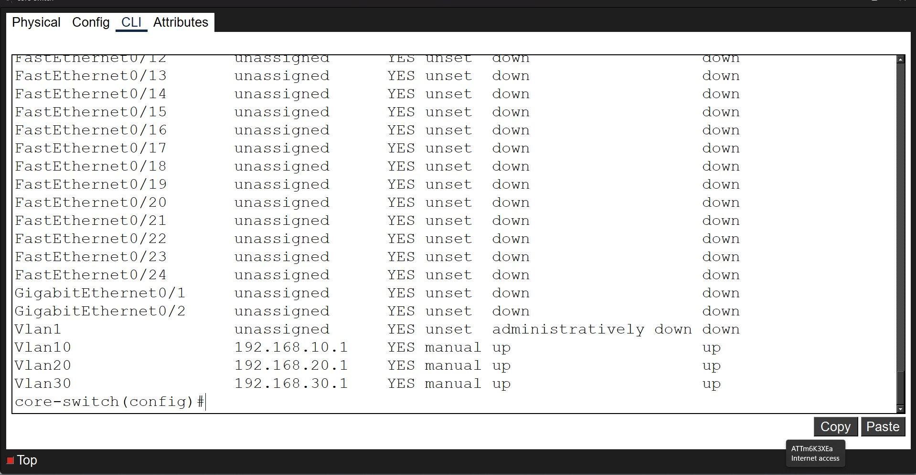
Figure 3, DHCP Pool Configuration—CLINICAL, ADMIN, and GUEST DHCP pools configured and saved (write memory [OK]).
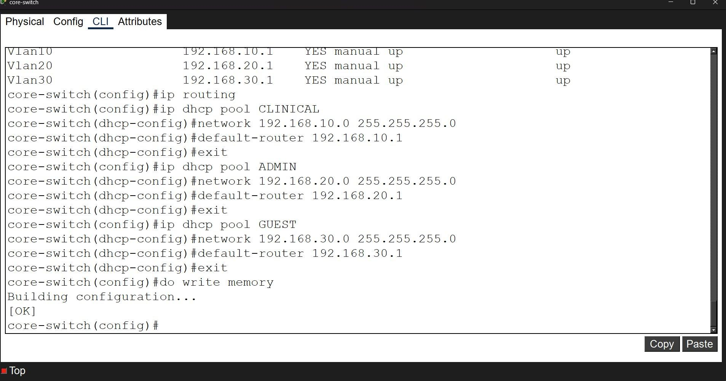
Figure 4. PC-Admin DHCP Verification–succeful DHCP request, assigned 192.168.20.2, gateway 192.168.20.1.
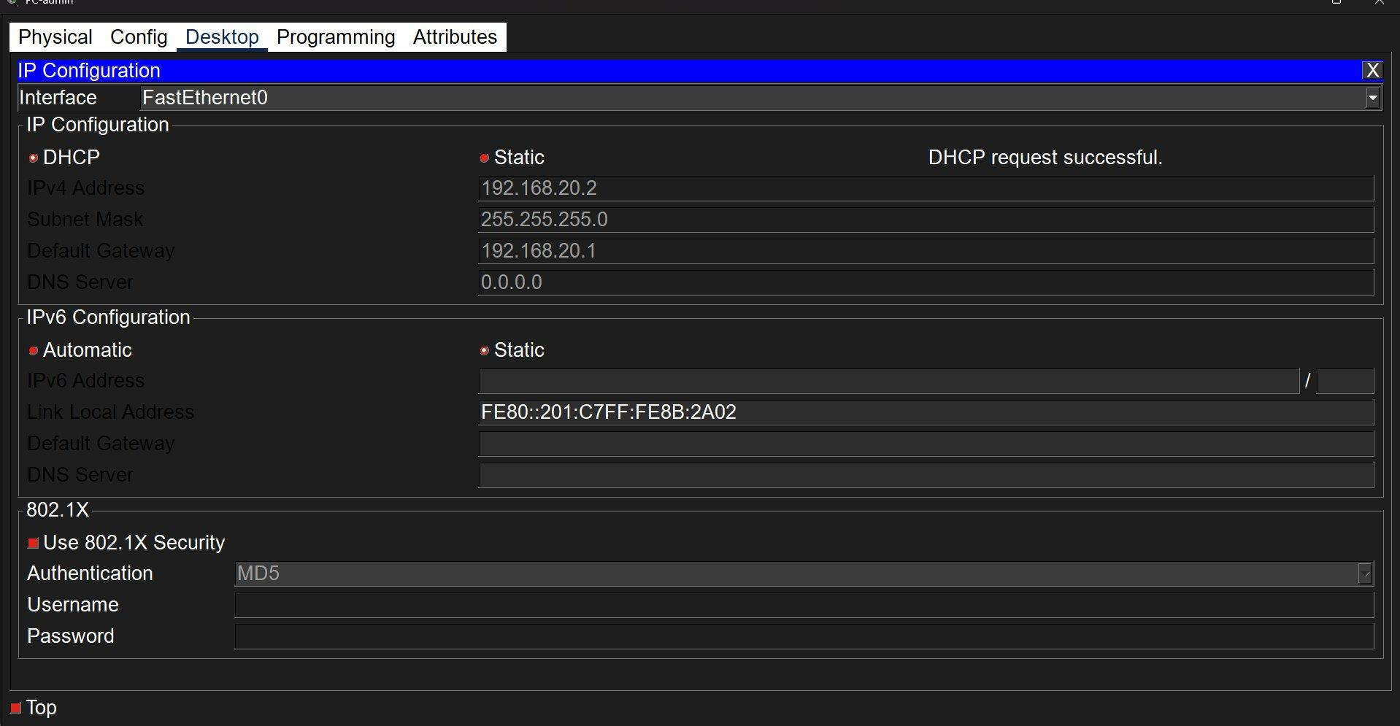
Figure 5. PC-Clinical DHCP Verification–succeful DHCP request, assigned 192.168.10.2, gateway 192.168.10.1.
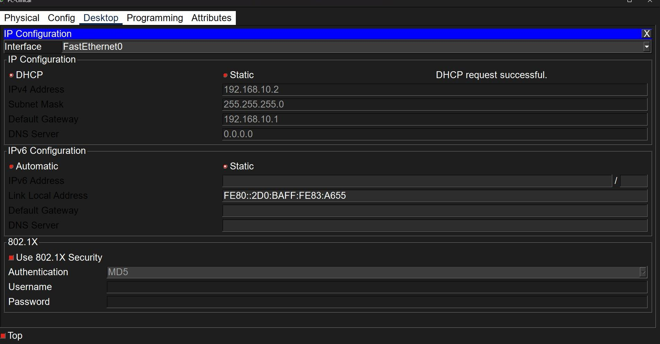
Figure 6. EHR-Server DHCP Verification–succeful DHCP request, assigned 192.168.10.3, gateway 192.168.10.1
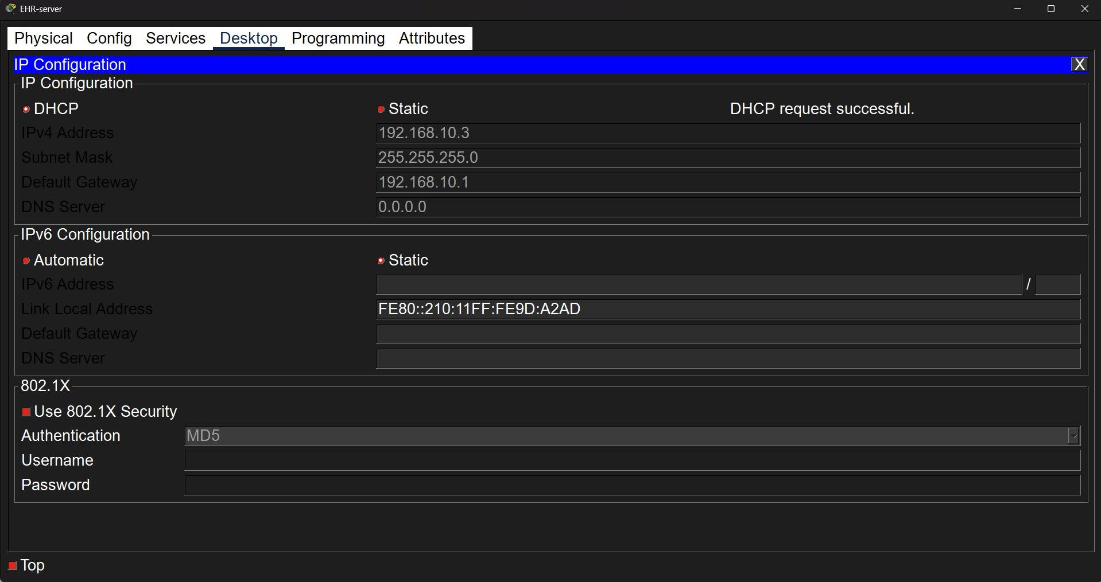
Figure 7. ACL Configuration—BLOCK_GUEST extended ACL rules applied to the VLAN 30 interface (IP Access-Group BLOCK_GUEST in), configuration saved [OK].
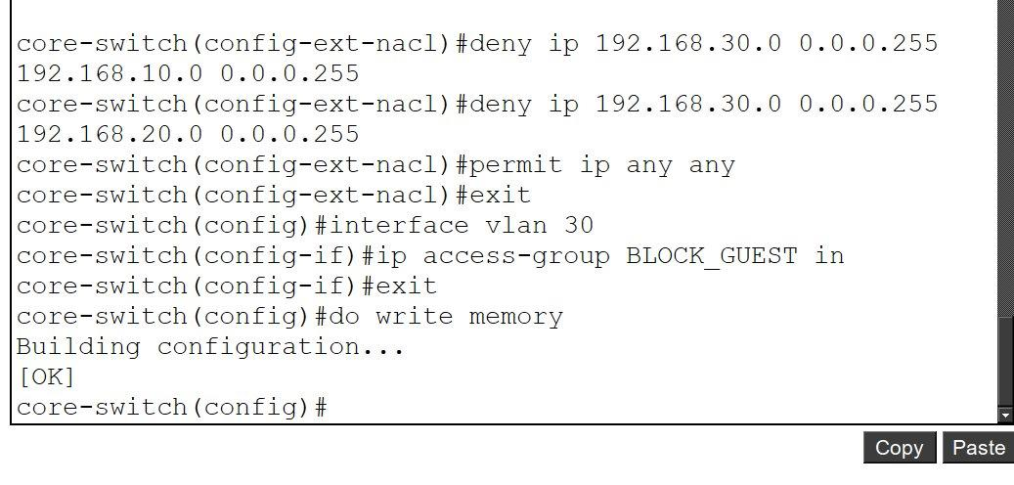
Figure 8. Guest Isolation Test (Critical)--ping from PC-Guest (192.168.30.10) to EHR Server (192.168.10.3): Sent=4, Received:0, Lost=4 (Loss 100%).
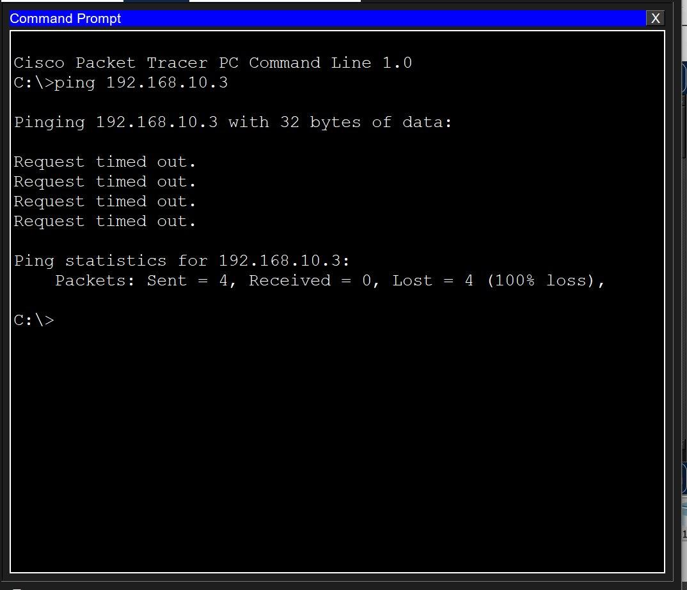
Figure 9. Clinical Access Verification– ping from PC-Clinical (192.168.10.2) to EHR Server (192.168.10.3): Sent=4, Received=4, Lost=0 (Loss 0%).
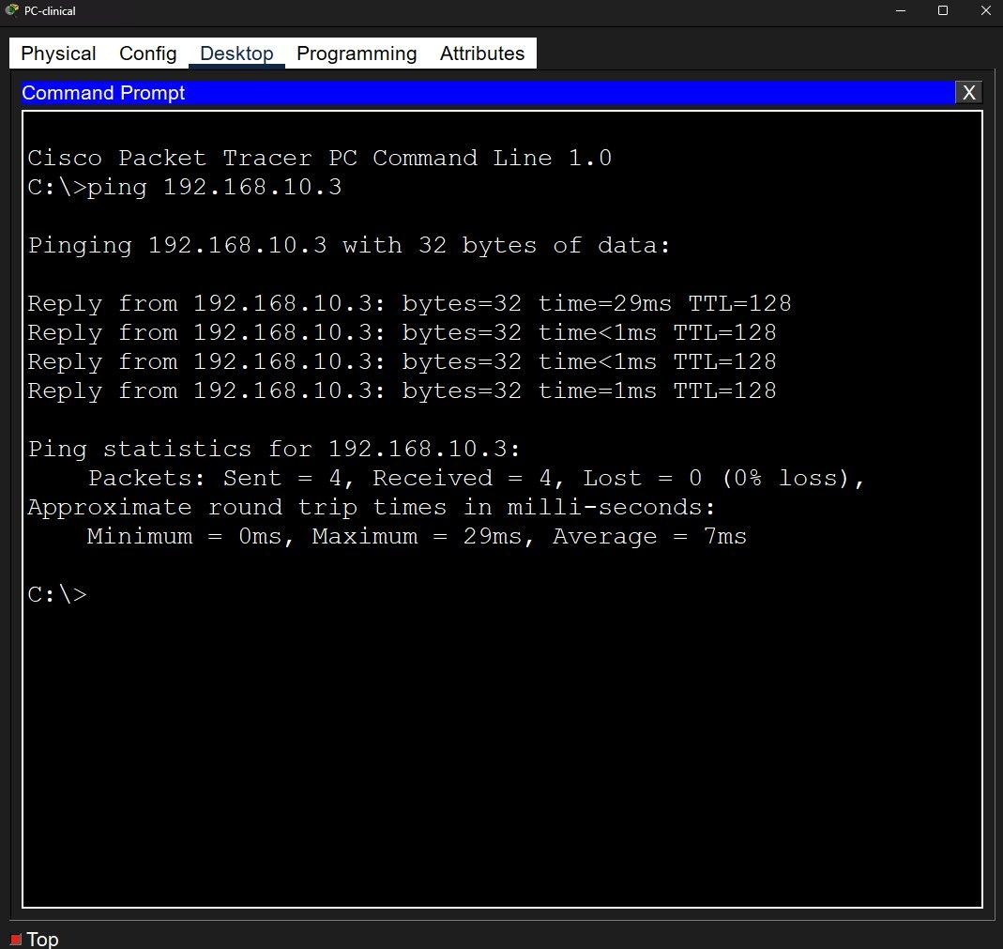
Figure 10. Network Topology Diagram–complete three-VLAN architecture produced in draw.io, illustrating device connections, port assignments, subnet labels, and the ACL BLOCK_GUEST enforcement layer.
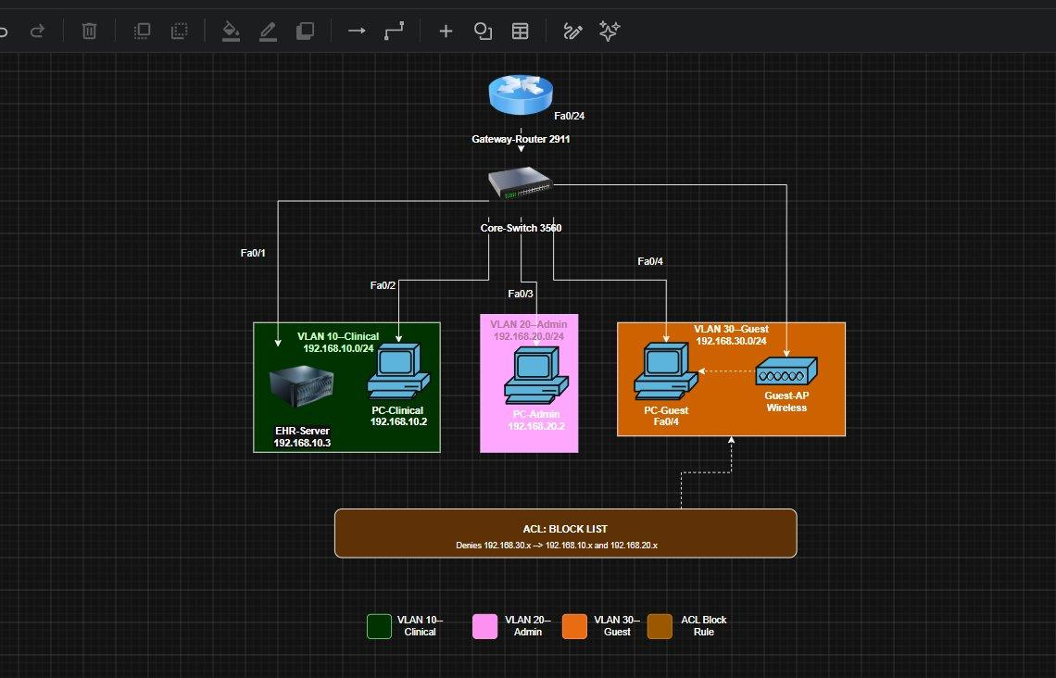

References
Cisco Systems. (2024). Cisco Packet Tracer. Cisco Networking Academy. https://www.netacad.com/courses/packet-tracer
National Institute of Standards and Technology. (2008). An introductory resource guide for implementing the Health Insurance Portability and Accountability Act (HIPAA) Security Rule (NIST SP 800-66). https://doi.org/10.6028/NIST.SP.800-66
National Institute of Standards and Technology. (2018). Framework for improving critical infrastructure cybersecurity (Version 1.1). https://doi.org/10.6028/NIST.CSWP.04162018
U.S. Department of Health and Human Services. (1996). Health Insurance Portability and Accountability Act of 1996 (HIPAA). https://www.hhs.gov/hipaa
U.S. Department of Health and Human Services. (2023). Healthcare sector cybersecurity: Introduction to the strategy of the U.S. Department of Health and Human Services. https://www.hhs.gov/sites/default/files/hhs-cybersecurity-strategy.pdf

